SmartCount Edge PLUS Recipe Load Barcode
This barcode must be scanned first, then scan the barcode of the recipe to load

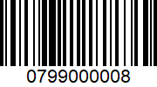

Easily create barcodes for each recipe at www.barcode.tec-it/en/code128

