_{Field Entry Codes}
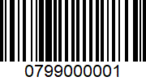  _{Optional Entry #1} | 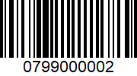  _{Optional Entry #2} | 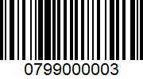  _{Optional Entry #3} | 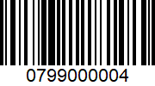  _{Optional Entry #4}
 | 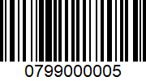  _{Optional Entry #5} | 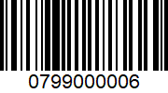  _{Optional Entry #6}
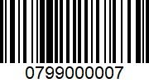
_{Cancel Entry}
_{Down Time Selection Codes}

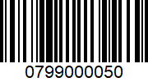  _{Down Time Status 0} | 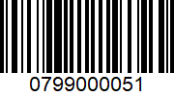  _{Down Time Status 1} | 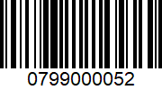  _{Down Time Status 2} | 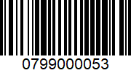  _{Down Time Status 3}
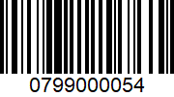  _{Down Time Status 4} | 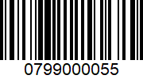  _{Down Time Status 5} | 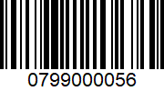  _{Down Time Status 6} | 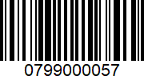  _{Down Time Status 7}
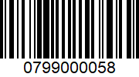
_{Down Time Status 8}

_{Mode Selection}
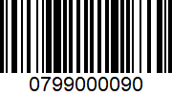  _{Pause/Resume} | 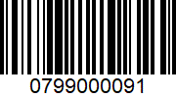  _{Setup Start/Stop}
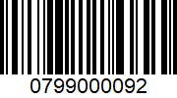
_{Reset}

_{Combo Field Entry Code}

_{Format:}
SETDATA_ENTRY01_ENTRY02_ENTRY03_ENTRY04_ENTRY05_ENTRY06

_{Example:}
SETDATA_John Doe_8914321564_Muffler Bearings_912315542_Second Shift Part Run_56

